Date: 15 March 2024

Name: PADAM SINGH

Trade: IBM-ADIT

Subject: Elective Module – 3 (Web Development using JS Framework)

Roll no: ADIT-97

Registration no: ADIT22AP00545

**Aim:** Create an Express app with 3 routes - /about, /home and /contact. Display separate html contents when the user accesses each route.

**Solution**

**Software/Requirement/Tools:**

* Operating System – Windows 10/11 or Linux
* Command Prompt/Power Shell
* Internet Connectivity, Browser (Chrome or Edge)
* Text Editor – Notepad / IDE – Visual Studio Code/Any IDE
* NodeJS, ExpressJS

**Step/Code:**

1. We need to create a folder. I have created a folder whose name is Elective Module 3.
2. Right-click on it and open it in the integrated Terminal.

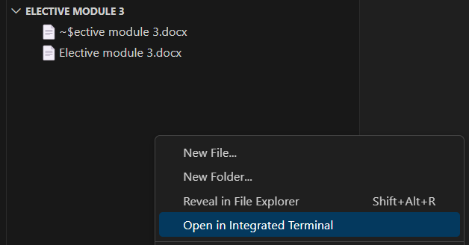

1. We need some packages to run these commands.

**npm init -y** (This command creates a package.json file).

**npm i express nodemon** (install the express and nodemon)

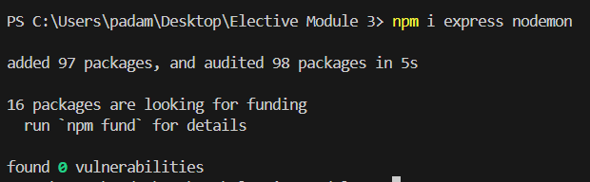

1. If you want to check whether packages are installed or not then open the package.json file and you can see your all-installed packages.

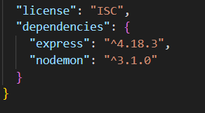

1. Create a file I give the name index.js and add this code inside of the **index.js**

**Code:**

|  |
| --- |
| // import the express module  const express = require('express')  const app = express();  // static files  app.use(express.static(__dirname + '/public'));  //route for home page  app.get('/home', (req, res) => {  res.sendFile(__dirname + '/index.html');  })  //route for about page  app.get('/about', (req,res)=>{  res.sendFile(__dirname + '/about.html');  })  //route for contact page  app.get('/contact', (req,res)=>{  // res.send('Welcome to the Contact page');  res.sendFile(__dirname + '/contact.html');  })  //start the server on port 3000  app.listen(3000);  console.log('listening on port 3000: http://localhost:3000/'); |

1. Now create index.html, about.html and contact.html and add this code inside the file.

**index.html**

|  |
| --- |
| <!doctype html>  <html lang="en">  <head>  <title>Home page</title>  <!-- Required meta tags -->  <meta charset="utf-8" />  <meta name="viewport" content="width=device-width, initial-scale=1, shrink-to-fit=no" />  <!-- Bootstrap CSS v5.2.1 -->  <link href="https://cdn.jsdelivr.net/npm/bootstrap@5.3.2/dist/css/bootstrap.min.css" rel="stylesheet"  integrity="sha384-T3c6CoIi6uLrA9TneNEoa7RxnatzjcDSCmG1MXxSR1GAsXEV/Dwwykc2MPK8M2HN" crossorigin="anonymous" />  <link rel="stylesheet" href="css/style.css">  </head>  <body>  <h1>Home Page</h1>  <p>Lorem ipsum, dolor sit amet consectetur adipisicing elit. Maxime voluptates illo hic vero cupiditate animi  quaerat dolore, labore at voluptatibus corrupti eum modi nulla eos fugiat dolores reiciendis error ipsam quis  maiores cum magni. Vitae omnis saepe reiciendis ab obcaecati, quod pariatur eos, iure corporis odit amet  delectus quibusdam, magni quasi esse eligendi vero totam culpa dolore molestias suscipit eum? Dolore natus  ducimus itaque doloremque voluptas cum. Blanditiis consequuntur maiores architecto, earum, iure mollitia tempore  quo facilis dolorem cupiditate voluptatem commodi vero officia reiciendis doloremque dolorum laudantium! Aliquam  eum assumenda sit accusantium porro sint rem quia dolores, libero, nulla magnam?</p>    </body>  </html> |

**about.html**

|  |
| --- |
| <!doctype html>  <html lang="en">  <head>  <title>About</title>  <!-- Required meta tags -->  <meta charset="utf-8" />  <meta  name="viewport"  content="width=device-width, initial-scale=1, shrink-to-fit=no"  />  <!-- Bootstrap CSS v5.2.1 -->  <link  href="https://cdn.jsdelivr.net/npm/bootstrap@5.3.2/dist/css/bootstrap.min.css"  rel="stylesheet"  integrity="sha384-T3c6CoIi6uLrA9TneNEoa7RxnatzjcDSCmG1MXxSR1GAsXEV/Dwwykc2MPK8M2HN"  crossorigin="anonymous"  />  <link rel="stylesheet" href="css/style.css">  </head>  <body>  <h1>About Page</h1>  <p>Lorem ipsum, dolor sit amet consectetur adipisicing elit. Maxime voluptates illo hic vero cupiditate animi  quaerat dolore, labore at voluptatibus corrupti eum modi nulla eos fugiat dolores reiciendis error ipsam quis  maiores cum magni. Vitae omnis saepe reiciendis ab obcaecati, quod pariatur eos, iure corporis odit amet  delectus quibusdam, magni quasi esse eligendi vero totam culpa dolore molestias suscipit eum? Dolore natus  ducimus itaque doloremque voluptas cum. Blanditiis consequuntur maiores architecto, earum, iure mollitia tempore  quo facilis dolorem cupiditate voluptatem commodi vero officia reiciendis doloremque dolorum laudantium! Aliquam  eum assumenda sit accusantium porro sint rem quia dolores, libero, nulla magnam?</p>    </body>  </html> |

**contact.html**

|  |
| --- |
| <!doctype html>  <html lang="en">  <head>  <title>Contact</title>  <!-- Required meta tags -->  <meta charset="utf-8" />  <meta  name="viewport"  content="width=device-width, initial-scale=1, shrink-to-fit=no"  />  <!-- Bootstrap CSS v5.2.1 -->  <link  href="https://cdn.jsdelivr.net/npm/bootstrap@5.3.2/dist/css/bootstrap.min.css"  rel="stylesheet"  integrity="sha384-T3c6CoIi6uLrA9TneNEoa7RxnatzjcDSCmG1MXxSR1GAsXEV/Dwwykc2MPK8M2HN"  crossorigin="anonymous"  />  <link rel="stylesheet" href="css/style.css">  </head>  <body>  <h1>Contact Page</h1>  <form action="">  <div class="mb-3">  Name:  <input type="name" class="form-control" name="" id="">  <label for="" class="form-label">Email</label>  <input  type="email"  class="form-control"  name=""  id=""  aria-describedby="emailHelpId"  placeholder="abc@mail.com"  />  <small id="emailHelpId" class="form-text text-muted"  >Help text</small  >  </div>  <input type="button" value="Submit" class="btn btn-primary" />    </form>  <!-- Bootstrap JavaScript Libraries -->    </body>  </html> |

1. Now what we need to do is create a **public** folder and inside of this folder create a folder **css**. Now create a **style.css** file.

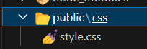

1. Add this code inside the **style.css** file

|  |
| --- |
| body{  margin-top: 5%;  }  h1{  color: green;  text-align: center;  font-size: 50px;  font-family: 'Gill Sans', 'Gill Sans MT', Calibri, 'Trebuchet MS', sans-serif;  }  p{  padding: 10%;  }  form{  padding: 10%;  } |

1. Now link the CSS to all .html pages and add this link to the all-html file.

|  |
| --- |
| <link rel="stylesheet" href="css/style.css"> |

1. Go to the terminal and run this command. Then click on the **http://localhost:3000/.**

**Set-ExecutionPolicy -Scope Process -ExecutionPolicy Bypass**

**nodemon index.js**

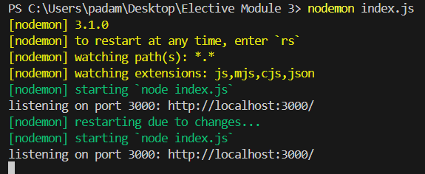

**Output:**

**/home**



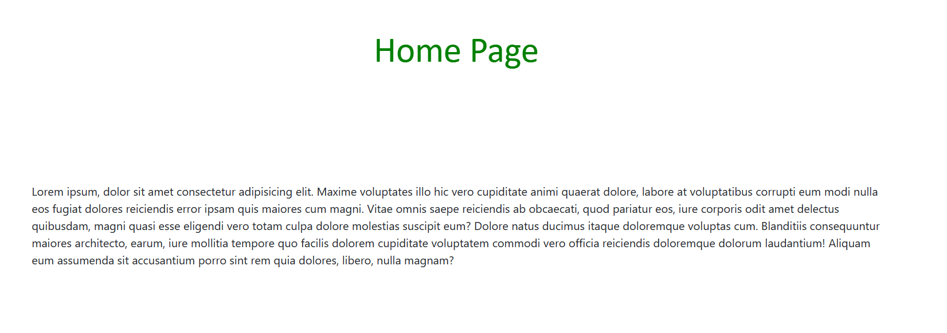

**/about**

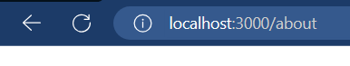

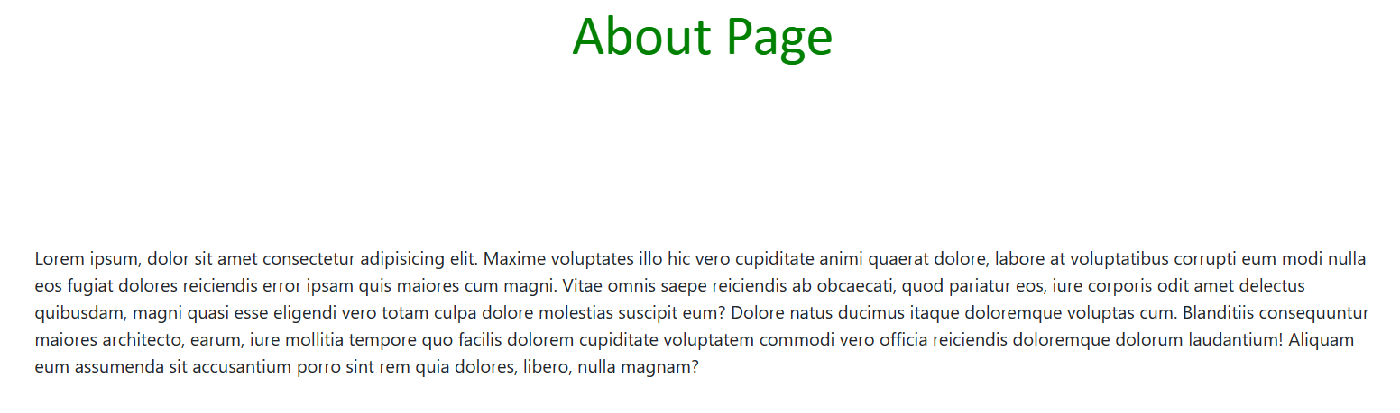

**/contact**

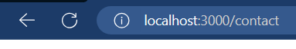

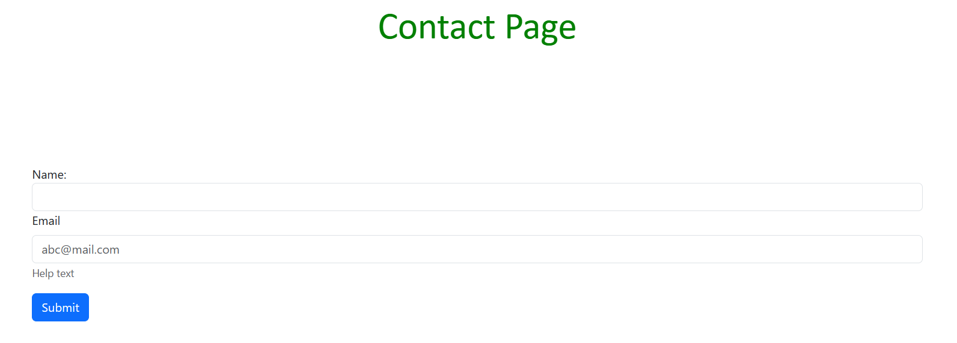

**Aim:** Create an Angular project and run it to display – “ Welcome to ADIT program” with font – “red”, font-size- 16 and inside header 1. Create a user-defined component such that the component’s HTML content – “Inside My Component” gets displayed in the main app’s HTML.

**Solution**

**Software/Requirement/Tools:**

* Operating System – Windows 10/11 or Linux
* Command Prompt/Power Shell
* Internet Connectivity, Browser (Chrome or Edge)
* Text Editor – Notepad / IDE – Visual Studio Code/Any IDE
* NodeJS, AngularJS

**Step/Code:**

1. Create an angular project. Simply right-click on the Elective Module 3 folder and open it in the terminal.
2. Run this command into the terminal.

**npm install -g @angular/cli** (This command installs the angular cli).

**Set-ExecutionPolicy -Scope Process -ExecutionPolicy Bypass**

**ng new project --no-standalone**

(This command creates a project in no standalone and if we are creating any **component** no need to add it inside the **app.module.ts** because it takes components automatically)



It’s taken some time to create.

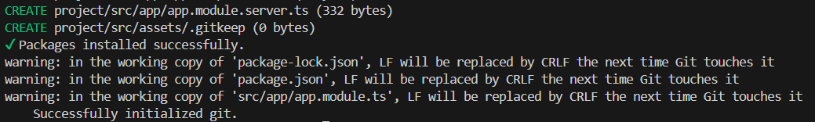

1. Now open the project folder in the terminal.

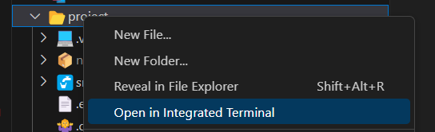

1. Run this command to check whether angular works or not.

**Set-ExecutionPolicy -Scope Process -ExecutionPolicy Bypass**

**ng serve**

Then click on the link

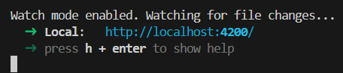

You can see your project works properly.

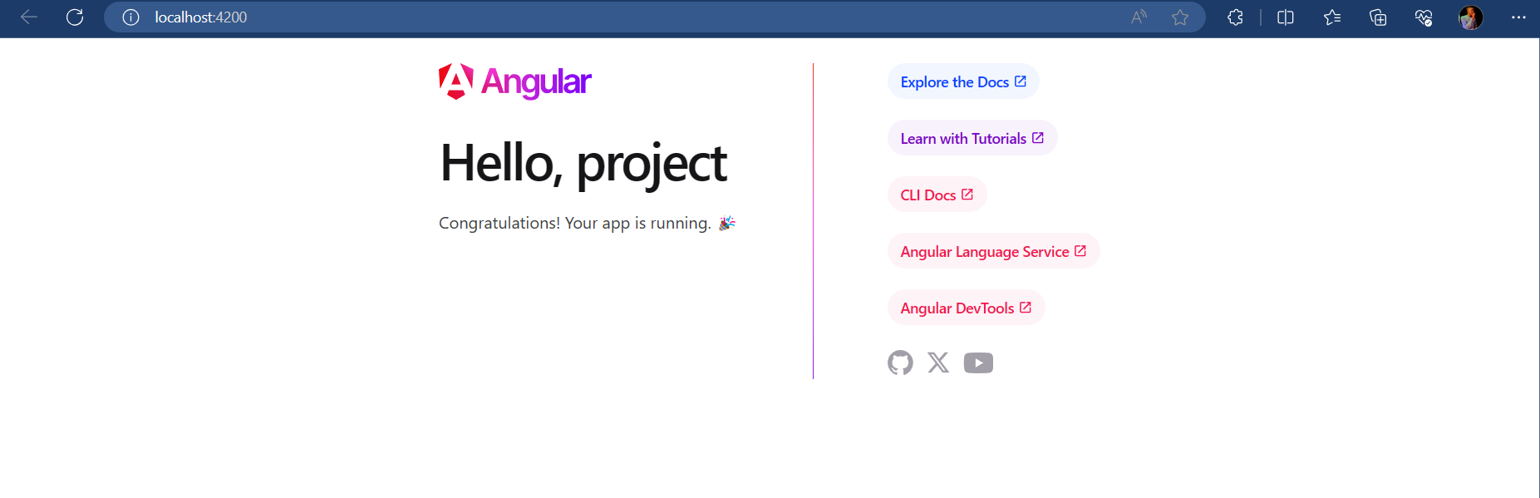

1. Our all-working files are in the **src** folder.

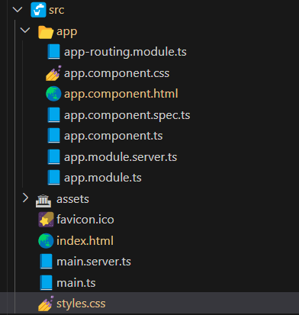

1. Now we need to display “**Welcome to ADIT program**”. For that add this code inside these files.

**src/app/app.component.html**

|  |
| --- |
| <h1>Welcome to ADIT program</h1> |

**src/assets/styles.css**

|  |
| --- |
| /* You can add global styles to this file, and also import other style files */  h1{  color: red;  font-size: 16;  } |

**Output:**

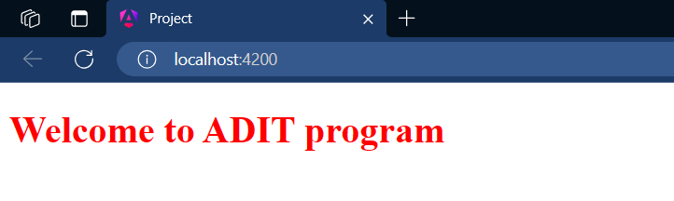

1. Now we need to create a component.
2. My component name is **userdefined** and run this command into the terminal.

**ng g c userdefined**

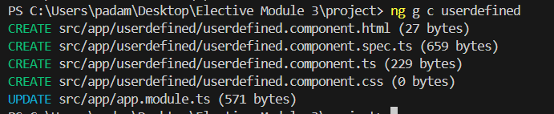

You can see a folder is created by this command and has component files.

1. Open the **userdefined.component.html** and add this code line.

|  |
| --- |
| <p>Inside My Component</p> |

1. Then go to the **src/app/app.component.html** and add this code line.

|  |
| --- |
| <header>  <app-userdefined />  </header> |

1. After all steps run the server by this command and click on the link.

**ng serve**

**Output:**

